**Journey Through The Bible**

**Woman at the Well**

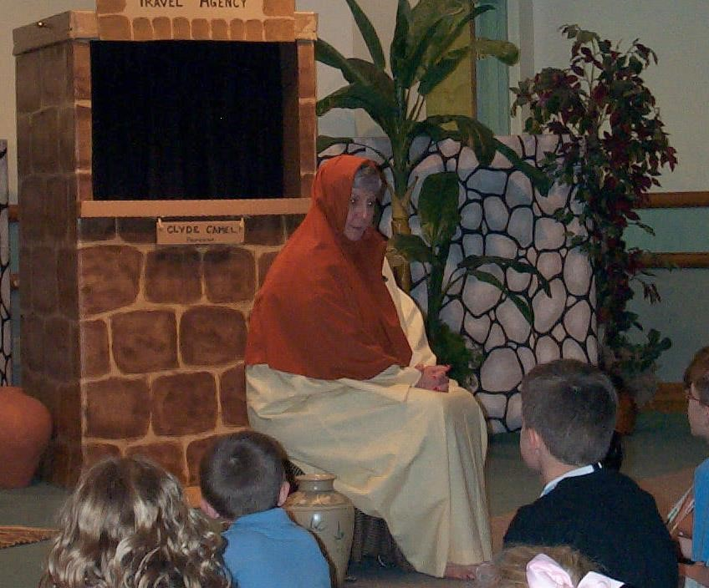

I am a Samaritan woman who lived in Sychar in Samaria. Each day I would go to Jacob’s well to draw water, for that was my only source of water.

One day about 12:00, as I came to get water, I saw a Jewish man sitting by the well. He seemed to be very tired as he said to me, “Give me a drink.” That surprised me greatly, because the Jews do not share things in common with Samaritans. I said, “How is it that you, a Jew, ask a drink of me, a woman of Samaria?”

I later found out that this man’s name was Jesus. Jesus said, “If you knew the gift of God and who it is that is saying to you, ‘Give me a drink,’ you would have asked Him, and He would have given you living water.”

Since I saw that this Jesus did not have a bucket, I asked Him where you could get that living water. Did He think that He was greater than Jacob, who gave us the well?

This man Jesus told me that whoever drank of the water in the well would be thirsty again, but those who drank of the water that He would give them would never thirst again. He then confused me when He said, “The water that I will give will become in those who drink a spring of water gushing up to eternal life.”

When this Jesus told me all about my life, I thought that He was a prophet. He also said that people would no longer have to worship the Father in Jerusalem or on a mountaintop. He said that the day was coming when those who worship God must worship Him in spirit and truth.

I said to Jesus, “I know that Messiah is coming” (Who is called Christ). “When He comes, He will proclaim all things to us.”

Jesus then said to me, “I am He, the One who is speaking to you.” Just then Jesus’ disciples came and asked Jesus why He was speaking to me.

I immediately left my water jar, went back to the people and told them, “Come and see a man who told me everything I have ever done! He cannot be the Messiah, can he?” All of the people left the city and went on their way to see Him.

I had truly met the Messiah, the Christ, the only Son of God, and I had to share with others the wonderful things that I had learned from Him.

We must all be sure to share with others the good news about Christ and His living water. Now I would like to ask you some questions. (Prepare a few questions to ask the boys and girls about your character.)

**Scripture reading**: John 4:1-43

**Memory Verse:** John 4:24

God is Spirit, and those who worship Him must worship in spirit and truth.

